Potential free contacts are also sometimes called volt free or “dry” contacts, and simply refer to relay contacts, or which or sensor contacts, which have not been wetted with voltage by the machine or device in which they exist.

设置十字光标，选择进入User Preference界面

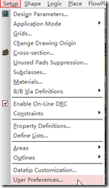

将Display 中的cursor 设置pcb_cursor为infinite，并选中Favorite。

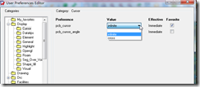

注：如果十字光标在鼠标移动时有阴影，则不使用OpenGL，

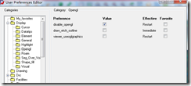

十字光标效果如下

